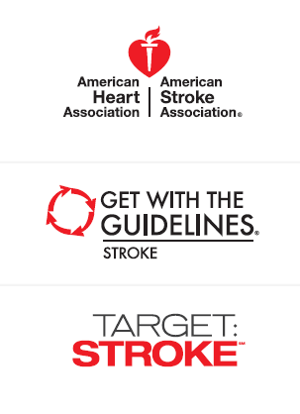
Goal 75% Target: Stroke Phase II aims to achieve DTN in 60 minutes in 75% or
more of acute ischemic stroke patients treated with IV tPA*

*Eligible Get With The Guidelines-Stroke/Target: Stroke acute
ischemic stroke patients treated between January 2014 to
December 2014

FEWER THAN 6 HOSPITALS PER STATE (too few to report) | State | Numerator/Denominator | Number of Hospitals Participating Per State
 | Alaska
 | Idaho
 | Iowa
 | Montana
 | New Mexico
 | South Dakota
 | Vermont
 | Wyoming

25-49% | State | Numerator/Denominator | Number of Hospitals Participating Per State
 | Arkansas | 42/114 | 18
 | Indiana | 129/295 | 22
 | New Hampshire | 16/47 | 6

50-74% | State | Numerator/Denominator | Number of Hospitals Participating Per State
 | Alabama | 84/138 | 19
 | California | 1436/2105 | 134
 | Connecticut | 133/213 | 12
 | Delaware | 59/105 | 6
 | Florida | 1005/1573 | 99
 | Georgia | 492/743 | 49
 | Hawaii | 75/102 | 9
 | Illinois | 298/498 | 53
 | Kansas | 97/144 | 13
 | Kentucky | 199/271 | 18
 | Louisiana | 110/183 | 10
 | Maine | 35/55 | 7
 | Maryland | 300/441 | 36
 | Massachusetts | 334/639 | 64
 | Michigan | 271/435 | 27
 | Minnesota | 107/168 | 6
 | Mississippi | 107/178 | 14
 | Missouri | 436/593 | 33
 | Nebraska | 21/39 | 7
 | Nevada | 79/158 | 13
 | New Jersey | 439/681 | 45
 | New York | 1228/1668 | 115
 | North Carolina | 417/594 | 31
 | North Dakota | 29/50 | 10
 | Ohio | 377/619 | 50
 | Oregon | 193/318 | 26
 | Pennsylvania | 584/1063 | 82
 | Puerto Rico (FL-PR Stroke Registry) | 859/1321 | 65
 | Rhode Island | 81/133 | 7
 | South Carolina | 257/397 | 23
 | Texas | 884/1403 | 95
 | Utah | 16/32 | 7
 | Virginia | 123/224 | 22
 | Washington | 318/438 | 37
 | West Virginia | 57/107 | 10
 | Wisconsin | 185/283 | 34
 | North Carolina | 417/594 | 31

75-100% | State | Numerator/Denominator | Number of Hospitals Participating Per State
 | Arizona | 398/530 | 28
 | Colorado | 291/368 | 20
 | Oklahoma | 144/179 | 6
 | Tennessee | 257/323 | 17

