Implementation Guide:
Check It! Challenge!

Table of

Contents

Check. Change. Control.® Overview 3
- Why the AHA Created CCC 3
- Key Features of CCC 3
- Roles in CCC 4
- Benefits of CCC 4
Activating the Experience 5
Promotion Phase 7
Implementation Phase 9
- Month 1 9
- Month 2 15
- Month 3 23
- Month 4 28
Frequently Asked Questions 33

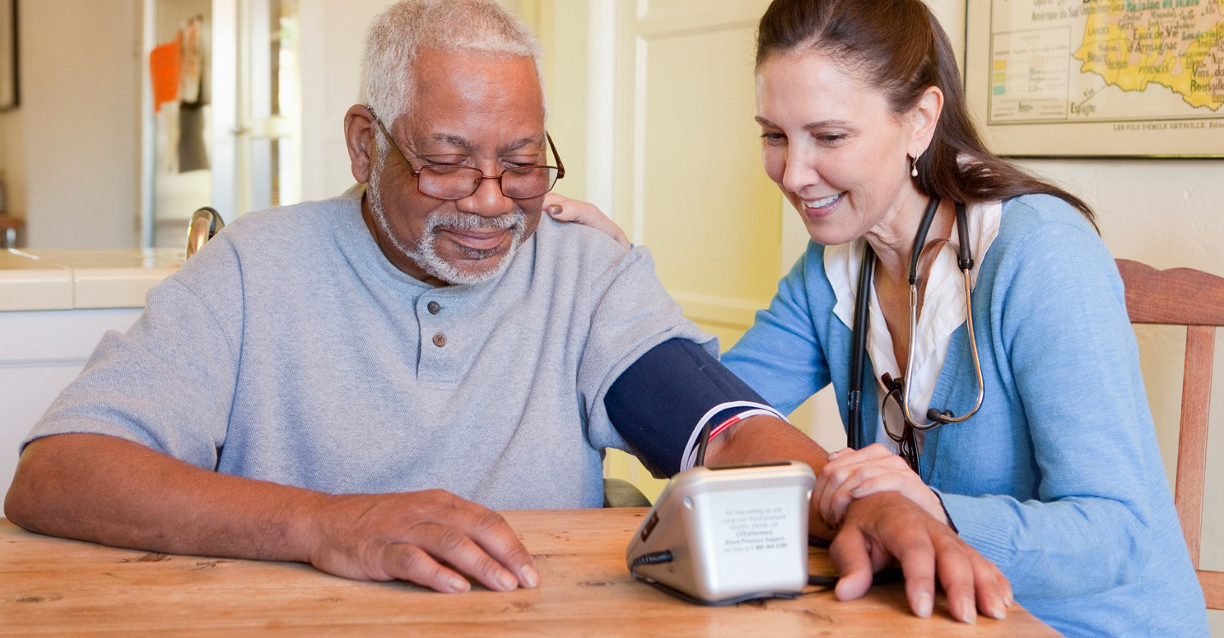
2022 | THE AMERICAN HEART ASSOCIATION | CHECK. CHANGE. CONTROL.® | OVERVIEW
3

CHECK. CHANGE. CONTROL.®
Check. Change. Control.® (CCC) Blood Pressure is an evidence-based high bloodpressure management program that empowers patients/participants to take charge of their cardiovascular health by self-monitoring their blood pressure. With the aim to eliminate blood pressure as a health disparity among Americans, the program provides participants knowledge to improve their blood pressure numbers — including core areas such as managing and tracking medication, moving more, eating heathy and taking care of their mental well-being.

WHY THE AHA CREATED CHECK. CHANGE. CONTROL.®
Every person deserves the opportunity for a full, healthy life. As champions for health equity, by 2024, the American Heart Association will advance cardiovascular health for all, including identifying and removing barriers to health care access and quality. To reach the goal, the AHA is encouraging more Americans to control their blood pressure.
122 million or 46% of U.S. adults have high blood pressure — a major health risk factor — and only 1 in 4 have their blood pressure under control. Undetected or uncontrolled high blood pressure can lead to future heart attack and stroke.
The AHA is also combatting health inequity. Structural racism is a major cause of poor health and early death from heart disease and stroke. The prevalence of high blood pressure in Black people in the U.S. is among the highest in the world — 55.8% among males and 56.9% among females. Black adults are more likely to have been told on two or more occasions that they had high blood pressure than American Indian/Alaska Native adults, white adults, Hispanic or Latino adults or Asian adults.

KEY FEATURES OF CHECK. CHANGE. CONTROL.®
- Participants set goals and track blood pressure and other lifestyle habits.
- The four-month high blood pressure self-monitoring program includes educational materials, including a participant resource guide.
- Participants have access to heart.org for resources such as articles, videos and fact sheets about chronic health conditions and management strategies.
- On-site Champions/Ambassadors encourage participation and serve with AHA staff.

ROLES IN CHECK. CHANGE. CONTROL.®
2022 | THE AMERICAN HEART ASSOCIATION | CHECK. CHANGE. CONTROL.® | OVERVIEW
4

ORGANIZATIONS:
- Designate an internal program lead (Check It! Champion) to serve as a liaison with AHA staff.
- Incorporate AHA wellness activities into existing schedule.

PARTICIPANTS:
- Commit to tracking blood pressure and other health habits at least twice a month for four consecutive months.
- Agree to communicate with the Check It! Champion throughout the four months.
- Participate in wellness activities and register for the monthly Community Conversations at www.heart.org/checkitNY

BENEFITS OF CHECK. CHANGE. CONTROL.®

ORGANIZATIONS:
- Create a culture of health throughout your organization.
- Engage participants in interactive educational experiences to develop healthy habits and reduce risk for heart disease and stroke.
- Build camaraderie among participants.

PARTICIPANTS:
- Support personal goals toward better health.
- Monitor and track progress.
- Have access to a blood pressure monitor (if made available by the site).
- Can be awarded prizes throughout the program (if made available by the site).

Let Us Help
1
First, connect with an American Heart Association representative to learn about the program, including a wide variety of educational resources.

Get Leadership Behind You
2
Get the buy-in of your organization’s leadership, such as the CEO, superintendent, human resources lead, health benefits manager, etc. to commit to improving health with a focus on blood pressure management.

Build Your Plan
3
Work with the AHA representative to organize your timeline and plan of action in your organization. This is your opportunity to schedule your Check It! Challenge kickoff, engagement dates and communication timeline. The AHA has a menu of engagement opportunities for implementing your program. We suggest at least one health activity per month to keep
the participants engaged.

Identify Champions/Ambassadors
4
Work within your organization to recruit volunteer Ambassadors to help recruit and facilitate the experience. Company wellness coordinators are a good fit for this role.

Host a Training Session for Champions/Ambassadors
5
Attend one of the three Check It! training sessions or contact checkitNY@heart.org to schedule a training session to learn about the Check It! Challenge experience.

Set Goals
6
Work with your wellness team and leadership to set recruitment goals, timelines and a plan of action for the program. The basics of the program have been established, but this is your time to customize the Check It! Challenge for you and your organization.

Get the Word Out
7
Create ways to get the word out. Work with your human resources, communications and wellness teams to discuss ways to communicate with potential participants. Ask your CEO
to send a company-wide email, memo or voicemail inviting staff to be a part of the program. Your existing communications may help leverage Challenge participation (company newsletter, wellness emails, breakroom postings, building information monitors/screens, etc.).

Recruit Participants to Take the Challenge
8
Now, it’s time to recruit participants for the Check It! Challenge program in your company. Your wellness team leads should start to recruit participants from their areas. Consider hosting a kickoff for participants. Create a registration form for participants or encourage participants to email your Check It! Champion to register. Great ways to encourage participation are:
- Challenge individuals to set goals.
- Create a competitive environment per department or location, launching contest with modest incentives to reward recruitment and retention.
- Integrate health engagement opportunities to create a richer experience and raise awareness (cooking demos, employee challenges, wellness points, etc.).

Implement Your Plan
9
Now that you have your plan of action and timeline, and recruited participants, it’s time to implement. Also, track your progress. Maintain monthly check-ins with your wellness
Champions/Ambassadors and remember your AHA representatives are available to support your efforts. You can also schedule reminder messages to your wellness Champions/ Ambassadors to make sure the program is running smoothly and to drive health improvement.

Celebrate Success
10
When you get great news about enrollment or receive a favorable report on your organization’s culture of health, celebrate! Wrap up the program with a bang with participants congratulating and celebrating each other’s achievements.

Ways to celebrate:

- The CEO congratulates the team via email or in person.
- Participants share their success stories of better health.
- Present awards in a ceremony to those with compelling health improvements and for participation.

QUICK PLANNING CHECKLIST
- Recruit and orient internal CCC Leads.
- Set a recruitment goal and incentives, if any.
- Ensure access to blood pressure monitors.
- Conduct a kickoff.
- Engage participants throughout the four months.
- Celebrate successes.

PROJECTED TIMELINE

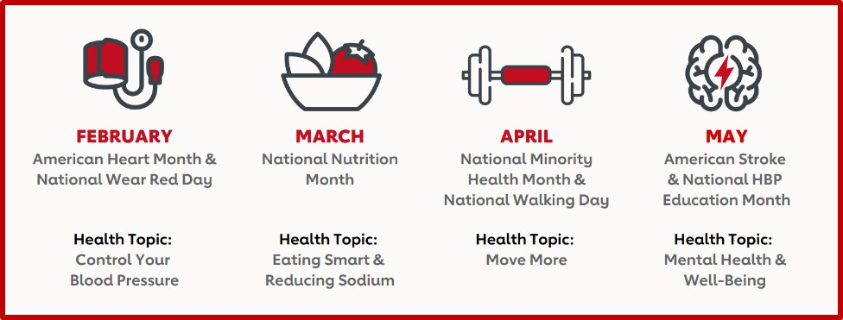
Kickoff Date: End Date:

WHAT? | WHEN? | WHO? | ADDITIONAL RESOURCES
Develop timeline with dates.
Begin recruiting program Champions/ Ambassadors and leadership support.
Schedule monthly check-in calls.
Determine incentive items, how to track participant engagement and dates incentives will be distributed. Consider incentives for program Champions/Ambassadors and participants. |  |  | Discuss incentives. Suggested items include: water bottles, fitness equipment, healthy recipes, gift cards, time off, casual dress days, etc.
Work with internal parties to design flyers. Post them when complete.
Host Check It! Champion/Ambassador/  Wellness Team Training. |  |  | Attend one of the pre- scheduled virtual Check Champion Trainings or contact AHA staff to schedule virtual training.
Host Check It! Champion/ Ambassador/Wellness Team Training No. 2 (optional) |  |  | Attend one of the pre- scheduled virtual Check Champion Trainings or contact AHA staff to schedule virtual training.
Send Promotion Message 1 for Check It! Challenge Kickoff. |  |  | Send emails to employees for Check It! Challenge Kickoff.
Send Promotion Message 2.

It!

It!

MESSAGING

PROMOTION MESSAGE 1
- Introducing the Check It! Challenge
- Message 1: [Should be sent 2-3 weeks prior to Kickoff]

SUBJECT: Exciting New Opportunity with the American Heart Association
Dear Check It! Challenge Participant,
I’m excited to be collaborating with the American Heart Association to bring the Check It! Challenge to (include organization name). The Check It! Challenge is rooted in Check. Change. Control.®, an evidence-based wellness and blood pressure management program. It focuses on improving health by making simple changes to prevent and manage high blood pressure. All are encouraged to sign up.
Sincerely, [Name, Title]

PROMOTION MESSAGE 2
- Introducing the Check It! Challenge
- Message 2: [Should be sent 1-2 weeks prior to Kickoff]

SUBJECT: Check It! Challenge Kickoff
Dear Check It! Challenge Participant,
High blood pressure is the “silent killer,” because it often doesn’t have symptoms. Knowing your blood pressure numbers and managing this condition is one of the best things you can do for your heart health. Join us (include virtual or in-person details) to get started!
For more information on blood pressure, visit the AHA website : ManageYourBP.org
Sincerely, [Name, Title]

(Suggested monthly topics)

MONTH 1 FOCUS: CONTROL YOUR BLOOD PRESSURE
Keeping blood pressure numbers in a normal range is important for your health — and for the health of those you care about. Everyone should know their blood pressure numbers and self-measure regularly. This lesson is for those who:

- May be at risk for uncontrolled high blood pressure.
- Have uncontrolled high blood pressure.

PPT LESSONS
Control Your Blood Pressure in English and Spanish

LEARNING MODULE
Let’s Talk About Blood Pressure

VIDEO CONTENT
Life’s Essential 8: Eight measures and behaviors scientifically proven to determine cardiovascular health (60 seconds)
How to Self-Monitor Your Blood Pressure (2 minutes, 52 seconds)
HBP Survivor Story: Alyson (1 minute, 22 seconds)
130 is to High for Blood Pressure Get Down With Your Blood Pressure
HBP and the Cardiovascular System
HBP Survivor Stories in Spanish (2 minutes, 11 seconds)

ANSWERS BY HEART
Metabolic Syndrome
African Americans and High Blood Pressure
- Know people with uncontrolled high blood pressure.
- Care for people with uncontrolled high blood pressure.

INFOGRAPHICS
Life’s Essential 8
What Can I do to Improve my Blood Pressure?
Lower Your Blood Pressure: Make the Most of Your Appointment
Consequences of High Blood Pressure English (PDF)
Spanish (PDF) Traditional Chinese (PDF)
Blood Pressure Measurement Instructions English (PDF)
Spanish (PDF) Traditional Chinese (PDF)
Blood Pressure Chart English (PDF) Spanish (PDF)
Traditional Chinese (PDF)

WEBSITES
Medication to Help Manage/ Lower Blood Pressure
Taking Your Meds as Directed
Validated Blood Pressure Monitoring Devices

EMAIL MESSAGES

MESSAGE 1

SUBJECT: Today’s the day — the first day of the Check It! Challenge
Dear Check It! Challenge Participant,
Thank you for participating in Check It! Challenge High blood pressure is mostly a symptomless condition, which is why it’s called the “silent killer.” Understanding your risk for heart attack or stroke can help you set your health goals. Visit the Check. Change. Control. Calculator to learn your risk.
The first step in managing your blood pressure is measuring it regularly and sharing results with your health care team. Track your blood pressure as directed by your health care team, using your preferred tracking tool. If you need help selecting a blood pressure tracking tool, read this tip sheet. You can also use this paper record log.
It’s important to use a blood pressure monitoring device that’s validated for clinical accuracy through an independent review process. You can use this list to select one. It’s also important to position your body properly for accurate measurements. Watch this video and see this handout to learn how to measure your blood pressure properly at home. This handout
will help you understand your readings. To support you in achieving your goals, you can also participate in three different supplemental 28-Day Challenges — “Manage Your Blood Pressure,” “Move More,” and “Eat Smart.” Each day of the journey is limited to one baby-step and lots of emotional rewards! We encourage you to register for one challenge at a time.
If you have questions, please contact me at [Check It! Champion name and contact information].
For more information on blood pressure, go to ManageYourBP.org.
Sincerely, [Name, Title]

MESSAGE 2

SUBJECT: Reminder to Log Your Blood Pressure Reading
Dear Check It! Challenge Participant,
The first step in controlling your blood pressure is knowing your numbers. By now, you should be starting to get in the habit of measuring your blood pressure at home and tracking it on your preferred health app or with this paper tracker.
Check out this blood pressure chart that you can also download or print for easy reference. Now it’s time to take action! If your blood pressure numbers fall in the elevated stage or above, make an appointment to see your doctor for an assessment.
Always refer back to the chart when you measure your blood pressure, so you know what range you are in. Blood pressure can change over time and the more proactive you can be to lower it the better!
If you have questions, please contact me at [Check It! Champion name and contact information]. For more information on blood pressure, go to ManageYourBP.org.
Sincerely, [Name, Title]

heart.org/bplevels

Blood pressure guidelines above are based on American Heart Association’s journal Hypertension published on Nov. 13, 2017.

MESSAGE 3

SUBJECT: Relax and Check Your Blood Pressure
Dear Check It! Challenge Participant,
It is so important to make sure you are getting the most accurate readings possible. Watch this video and see this handout to learn more about how to measure your blood pressure properly at home.
Here are some of the basics:
- Don’t smoke, exercise, or drink caffeinated beverages or alcohol within thirty minutes of measurement.
- Wait at least 30 minutes after a meal.
- If you’re on blood pressure medication, wait to take your medication until after your measure your blood pressure.
- Empty your bladder.
- Rest in a chair for at least five minutes with your arm resting comfortably on a flat surface at heart level.
- Sit calmly and don’t talk or actively listen.
- Take two or three measurements, one minute apart.
- Sit still in a chair with your feet flat on the floor and your back straight and supported.
- Make sure you’re relaxed.
That last one can be challenging sometimes. We all have stress — at work, at home and on the road. Negative stress can keep you from feeling and performing your best — mentally, physically, and emotionally. No one’s life is completely stress-free. It’s important to know how to manage the stress in your life. Take a look at the Fight Stress infographic with tips on how to fight stress with healthy habits!
If you have questions, please contact me at [Check It! Champion name and contact information]. For more information on blood pressure, go to ManageYourBP.org.
Sincerely, [Name, Title]

MESSAGE 4

SUBJECT: Managing High Blood Pressure
Dear Check It! Challenge Participant,
If your blood pressure numbers fall in the elevated stage or above, make an appointment to see your doctor for an assessment. Your healthcare provider is your partner. They would be delighted to go over your numbers and provide some one-on-one coaching. Depending on the situation, they might recommend lifestyle changes and/or medications to help you lower your blood pressure.
If you have been diagnosed with high blood pressure (HBP) by a health care professional, you may have been prescribed medication to help manage and lower your blood pressure. It is estimated that three out of four Americans do not take their medication as directed. Poor medication adherence takes the lives of 125,000 people in America annually and costs the
health care system nearly $300 billion a year in additional doctor visits, emergency room visits, and hospitalizations. Don’t just stop taking your medications, talk with your doctor first. Learn more about high blood pressure medications in the What is HBP Medicine resource.
If you have questions, please contact me at [Check It! Champion name and contact information]. For more information on blood pressure, go to ManageYourBP.org.
Sincerely, [Name, Title]

2022 | THE AMERICAN HEART ASSOCIATION | CHECK. CHANGE. CONTROL.® | IMPLEMENTATION PHASE | MONTH 1
14

ACTIVITIES
- Additional HBP information messaging
- Ideas for lunch and learn content
- Learn how family history might put some at risk for high blood pressure. If family members have heart disease or stroke, their risk may be higher. Have participants ask family members whether they have HBP and develop a family tree. Learn about other non-modifiable risk factors: advanced age, ethnicity and gender.
- Learn about medications that can help lower and manage blood pressure. If your participants have been diagnosed with HBP by a health care professional, they may have been prescribed medication to help manage and lower their blood pressure. Studies
have shown that 3 out of 4 U.S. adults don’t take their medication as prescribed. Poor medication adherence takes the lives of 125,000 people in America annually, and costs the health care system nearly $300 billion a year in additional doctor visits, emergency department visits and hospitalizations.

2022 | THE AMERICAN HEART ASSOCIATION | CHECK. CHANGE. CONTROL.® | IMPLEMENTATION PHASE | MONTH 2
15

(Suggested monthly topics)

MONTH 2 FOCUS: EAT SMART
Heart-healthy eating is all about balance — it’s not all or nothing. Here are the top ten recommendations on eating smart from the AHA:
  - Balance calories eaten with physical activity
  - Choose a variety of fruits and vegetables
  - Choose whole grains
  - Include healthy protein sources, mostly plants and seafood
  - Use liquid non-tropical plant oils
  - Choose minimally processed foods
  - Minimize added sugars
  - Choose or prepare foods with little or no salt
  - Limit alcohol
Apply this guidance wherever you eat!

PPT LESSONS
Salt and Cardiovascular Risk in English and Spanish
Eating Smart with Fruit and Vegetables in English and Spanish

VIDEO CONTENT
Food and Your Health: Blood Pressure Video (1 minute, 53 seconds)
The video guides you through an animated heart showing the anatomy of how high blood pressure is developed. It shares common causes and consequences of high blood pressure and how food can impact overall health and help lower blood pressure to a healthy range.
Healthy Recipes Swaps (1 minute, 51 seconds)
This video teaches ingredient swaps, which are an easy way to make meals healthy. Check out some simple ideas that won’t cut out great taste.
Healthy Snacking (2 minutes)
This video provides 4 tasty and healthy tips for snacking.
What is a Serving? (1 minute, 36 seconds)
The video guides you through what a serving looks like for grains, vegetables, fruits, protein and dairy.

FOOD DEMONSTRATION VIDEOS — ENGLISH
2022 | THE AMERICAN HEART ASSOCIATION | CHECK. CHANGE. CONTROL.® | IMPLEMENTATION PHASE | MONTH 2
16
Baked Cajun Catfish and Easy Collard Greens
Black-Eyed Pea, Corn and Rice Salad Spicy Pumpkin Burritos
Chicken Shawarma Mediterranean Salad Chinese Chicken Stir-Fry Chicken Zucchini Enchiladas Turkey Picadillo

FOOD DEMONSTRATION VIDEOS — SPANISH
Bagre horneado al cajún y col forrajera sencilla
Ensalada de arroz, maíz y frijol de ojo negro Burritos de calabaza picantes
Shawarma de pollo Ensalada mediterránea Sofrito de pollo chino Picadillo de pavo
Enchiladas de calabacín y de pollo

INFOGRAPHICS — ENGLISH
2022 | THE AMERICAN HEART ASSOCIATION | CHECK. CHANGE. CONTROL.® | IMPLEMENTATION PHASE | MONTH 2
17
Effects of Excess Sodium Sodium Myths Busted Eat Smart – Food Label
Fruits and Vegetables Serving Size Easy Meal Prep
Build a Healthier Salad
5 Reasons to Eat More Color 4 Ways to Get Good Fats
Add Color with Fruits & Vegetables: How To Guide
Look for the Heart-Check Mark Building Healthy Habits at Work
The Ten Ways to Improve Your Heart Health Infographic

ANSWERS BY HEART
Why Should I Limit Sodium?

WEBSITES
Heart-Check Certified Recipes Certified Foods in the Grocery Store Recipes
Losing Weight
Let’s Cook Together Healthy Eating Making Habits Stick

INFOGRAPHICS — SPANISH
10 maneras de mejorar tu salud cardíaca 5 Razones Para Comer Más Color Alimentos de Temporada
Cambie su consumo de sal en 21 días
Coma Sabiamente a las Etiquetas de Informacion Nutricional
Combata El Estrés Con Habitos Saludables Compre de forma racional y ahorre Cuánto es una Porción
Desmintiendo 7 mitos del sodio Elija su Propio Entrenamiento Elimine los azúcares añadidos El sodio puede ser engañoso
Ingredientes esenciales para la preparación de comidas saludables para el corazón
¡La vida es dulce con estos fáciles sustitutos de azúcar!
Cómo demasiado sodio afecta su salud Manténgalo Fresco
Porciones de Proteina
Prepare una ensalada más sana
¿Quiere comer bien?
Sodio: Mitos y realidades para niños

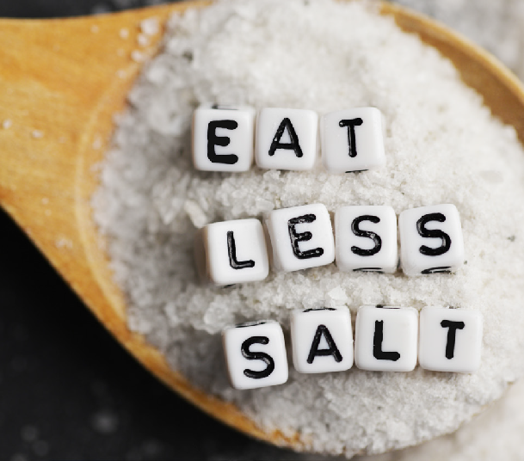
2022 | THE AMERICAN HEART ASSOCIATION | CHECK. CHANGE. CONTROL.® | IMPLEMENTATION PHASE | MONTH 2
18

EMAIL MESSAGES

MESSAGE 1

SUBJECT: Reduce Sodium to Improve Your Blood Pressure
Dear Check It! Challenge Participant,
Most of us don’t even realize how much salt we’re consuming. Salt can sneak up on us mostly when we eat restaurant or packaged foods. Check out this handy infographic to see for yourself: Sodium Can Be Sneaky.
The excess amounts of sodium we’re eating put us at risk for high blood pressure — increasing the risk of heart disease and stroke.
Don’t forget to keep building your healthy habits and logging your progress with a tracker that works best for you. Record your BP readings.
For more information, be sure to check out the AHA’s eat smart resources. If you have questions, please contact me at [Check It! Champion name and contact information].
Sincerely, [Name, Title]

MESSAGE 2

SUBJECT: Healthy Snacks
Dear Check It! Challenge Participant,
Most of the sodium in our diets comes from packaged, processed foods. Eating these foods less often can help reduce your sodium intake, lower your blood pressure and/or prevent high blood pressure from developing.
Call to Action: Your challenge this week is to swap your normal snack foods for healthy snacks such as fresh fruits and vegetables. Some convenient options include sliced apples, cutie oranges, carrots and celery sticks. Don’t forget to keep building your healthy habits and logging your progress using a tracker that works best for you. Record your BP readings.
For more information, be sure to check out the AHA’s eat smart resources. If you have questions, please contact me at [Check It! Champion name and contact information].
Sincerely, [Name, Title]

MESSAGE 3

SUBJECT: Make Every Bite a Meditation
Dear Check It! Challenge Participant,
Great job tracking those blood pressure readings!
Mental health includes our emotional, psychological, and social well-being. It affects how we think, feel, and act. It also helps determine how we handle stress, relate to others, and make choices. Did know that your mental health can affect your heart? Stress can increase hormones such as adrenaline and cortisol and can impact your blood pressure and heart rate.
Mindfulness has become as buzzworthy as cold pressed coffee — but there is good reason — it can help reduce stress and improve mental well-being.
If you want to put healthier eating habits on the menu, mindfulness may be a simple and effective place to start. It’s not about dieting or restrictions – it’s about taking a moment to take it all in. Mindful eating helps you savor the flavor and pay attention to the food you consume. This Mindful Eating infographic discusses how you can combine mindful eating into your daily habits.
For more information, be sure to check out the AHA’s Be Well resources.
Sincerely, [Name, Title]

MESSAGE 4

SUBJECT: Eat Smart — It’s Good for Your Heart
Dear Check It! Challenge Participant,
Keep tracking your blood pressure readings! Did you know adding fruits and veggies to your plate is one of the best ways to help lower your risk for many serious health conditions, including heart disease?
Start by adding just one more serving of fruits and veggies to your day. Not sure what counts as a serving? Don’t worry, learn more about fruit and veggie serving sizes here.
One of the best ways to add more color to your plate is by cooking at home. We have resources to help you with healthy meal prep, building a healthier salad, and a free recipe hub to help you try all kinds of new foods.
Sincerely, [Name, Title]

ACTIVITIES
- Reminder to keep tracking (including blood pressure)
- Snack Swap Challenge
- Learn about modifiable risk factors for chronic conditions, including high blood pressure
  - Lack of physical activity
  - An unhealthy diet
  - Being overweight or obese
  - Drinking too much alcohol
- Pay attention to modifiable behaviors. Encourage participants to reflect on lifestyle habits that may be getting in the way of good health. Maybe we’re eating too many processed foods. Maybe we’re not moving our bodies enough. These can be sensitive subjects, so avoid placing blame and encourage them to make small, positive changes.
  - Recommend practicing the 10 ways to improve heart health.
  - Offer resources to prevent and treat HBP or reduce their risk.
  - Give recipes that are lower in sodium.
  - Learn how to understand food nutrition labels.
- Encourage participants to set a small goal and track in a way that works best for them. Changes could be as simple adding a vegetable or fruit to every meal.
Participants with high blood pressure are encouraged to continue tracking their blood pressure as directed by their health care team, whether on a paper log or digitally.

ACTIVITIES
  - Healthy potluck
  - Sodium challenge or healthy recipe contest
  - Cooking demonstration or on-site farmer’s market
  - On-site nutrition coach/dietitian

(Suggested monthly topics)

MONTH 3 FOCUS: MOVE MORE
Establish a physical activity plan that complies with American Heart Association recommendations.

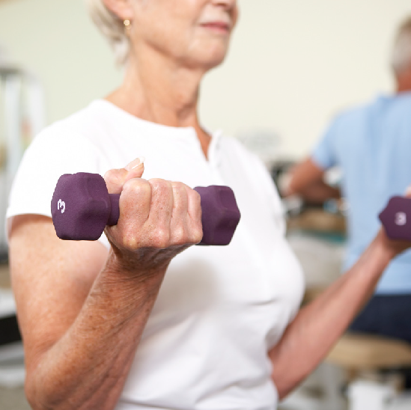
PPT LESSONS
2022 | THE AMERICAN HEART ASSOCIATION | CHECK. CHANGE. CONTROL.® | IMPLEMENTATION PHASE | MONTH 3
23
Get Active, Understanding and Utilizing Activity Guidelines in English and Spanish

INFOGRAPHICS — ENGLISH
Physical Activity Recommendation Get into Working Out
Make Every Move Count Keep Your Feet Happy
Is Your Workout Working? 25 Ways to Move at Home Whole Body Health Home Circuit Workout Cool-Weather Workouts
How to Keep Cool During Warm Weather Workouts
Move More with Your Pet

INFOGRAPHICS — SPANISH
Elija su Propio Entrenamiento
¿Qué cantidad de actividad física es necesaria? 25 Formas de Ponerte en Movimiento en Casa

VIDEOS
AHA Move More Introduction AHA Move More: Dips
AHA Move More: Lunges AHA Move More: Sofa Stretch AHA Move More: Torso Twist AHA Move More: Stop Sitting

ANSWERS BY HEART
How Can Physical Activity Become a Way of Life?

WEBSITES
Move More Together Fitness Basics Getting Active
10-Minute Home Workout
No Time for Workout – 7 Easy Ways Walking
Staying Motivated Active During Work Day Making Habits Stick

EMAIL MESSAGES

MESSAGE 1

SUBJECT: Get Active!
Dear Check It! Challenge Participant,
Every day is a new opportunity to make healthy choices! Along with a healthy diet, being physically active is another way to fight heart disease. Being more active can help us think, feel and sleep better and perform daily tasks more easily. So, let’s get moving!
Call to Action: Set time aside to move this week. Walking during breaks or lunch is a great way to get started. Also, check out the American Heart Association’s recommendations for physical activity and getting active.
Don’t forget to keep building your healthy habits and logging your progress using a tracker that works best for you. Record your BP readings.
For more information, be sure to check out the AHA’s move more resources. If you have questions, please contact me at [Check It! Champion name and contact information].
Sincerely, [Name, Title]

MESSAGE 2

SUBJECT: Get Energy to Move More
Dear Check It! Challenge Participant,
Ever been too tired to move more? Try hydrating before, during and after exercise or fueling up with snacks on healthy carbs such as vegetables, fruits and whole grains.
It can also help to alternate between sitting and standing throughout the day to fight fatigue and re-energize yourself.
Check out this Power Up to Move More infographic for more tips.
For more information, be sure to check out the AHA’s move more resources. If you have questions, please contact me at [Check It! Champion name and contact information].
Sincerely, [Name, Title]

EMAIL MESSAGES

MESSAGE 3

SUBJECT: Move More to Reduce Your Risk
Dear Check It! Challenge Participant,
You don’t have to run a marathon or go jogging every day to benefit from getting more active. Research shows that any activity — even small, short bouts — will provide health benefits. Even if you’ve been inactive and start exercising, you will benefit. Or, if you’re already active, adding more movement adds even more benefit.
Adding physical activity to your day doesn’t have to be expensive. You can create your own workout circuit at home, add in some lunges, or take a little dance break without any additional equipment at all. For more information, be sure to check out the AHA’s move more resources.
Sincerely, [Name, Title]

MESSAGE 4

SUBJECT: Boost Your Activity
Dear Check It! Challenge Participant,
Sometimes it can be challenging to fit in exercise in an already busy schedule. The good news it that you don’t have to do all your physical activity at once.
Try taking your dog or family on a walk and explore your neighborhood or walk and talk during work calls or calls with friends and family.
You can even add some extra movement to your day by taking the stairs or walk in place while watching TV.
For more information, be sure to check out the AHA’s move more resources.
If you have questions, please contact me at [Check It! Champion name and contact information].
Sincerely, [Name, Title]

2022 | THE AMERICAN HEART ASSOCIATION | CHECK. CHANGE. CONTROL.® | IMPLEMENTATION PHASE | MONTH 3
27

ACTIVITIES
- Additional messaging
- Lunch and learn content
During the third month of the Check It! Challenge experience, your participants have been continuing to track the changes they’re making to build healthy habits such as measuring their blood pressure, eating healthy and moving more. This is a great time to share additional resources on basic heart health.
- Learn about possible health consequences over time when high blood pressure is left untreated:
  - Damage to the heart and coronary arteries, including heart attack, heart disease, congestive heart failure, aortic dissection and atherosclerosis (fatty buildups in the arteries that cause them to harden)
  - Stroke
  - Kidney damage
  - Angina
  - Peripheral artery disease
Remember, these are not symptoms of HBP. It’s a symptomless disease except in the most extreme cases known as hypertensive crisis. When BP readings rise to 180 or above for the systolic (top) number OR 120 or above for the diastolic (bottom) number, call your doctor immediately.

ACTIVITY IDEAS:
  - Encourage walking meetings and/or start a walking club.
  - Host on-site exercise classes or a flash mob.
  - Do a physical activity challenge between teams or departments.
  - Start a company team for a community event promoting physical activity — such as the Heart Walk.

(Suggested monthly topics)

MONTH 4 FOCUS: MENTAL HEALTH AND WELL-BEING
Mental health includes our emotional, psychological and social well-being. It affects how we think, feel and act. It also helps determine how we handle stress, relate to to to others and make choices.

INFOGRAPHICS — ENGLISH
Best Friend Fridays Infographic How to Boost Willpower Infographic
Loving Kindness Meditation Infographic Mindful Eating Infographic
How Sleep Affects Your Health Infographic How to Sleep Better Infographic
Sleep Well Infographic
Fight Stress with Healthy Habits Infographic JOMO: The Joy of Missing Out Infographic Self-Care Isn’t Selfish Infographic
Stressed Out Infographic
Tips to Lower Stress Infographic Women and Stress Infographic

INFOGRAPHICS — SPANISH
Combatir El Estrés

VIDEOS
Managing Stress Meditation & Heart Risk Best Friend Fridays
Adopt a Dog - Good for Heart Dog Owners Live Longer Mindful Meditation
Mindful Meditation 2
Mindful Meditation 3
Mindful Meditation 4
Find a moment of relief from stress Take a moment to lower your stress

PODCAST
Live Fierce (Atrévete A Vivir) Podcasts

ANSWERS BY HEART
How Can I Manage Stress?

WEBSITE
Mental Health and Well-Being Sleep
Meditation
Mental Health & Your Heart Mindful Eating
How to Boost Willpower
How Sleep Affects Health Sleep Well Making Habits Stick
Stress Management

EMAIL MESSAGES

MESSAGE 1

SUBJECT: Take Care of Your Body AND Mind!
Dear Check It! Challenge Participant,
Mental health includes our emotional, psychological and social well-being. It affects how we think, feel and act. It also helps determine how we handle stress, relate to others and make choices. Many forms of mental health issues can affect our hearts. Stress can increase hormones such as adrenaline and cortisol and can impact your blood pressure and heart rate.
Call to Action: Reflect on what’s causing you stress or anxiety and share with a friend or loved one. Don’t hesitate to reach out for professional mental health support if needed. And be sure to keep building your healthy habits and logging your progress using a tracker that works best for you. Record your BP readings.
Need a place to connect with others? Consider joining the American Heart Association’s Support Network. You can share your story with others and connect with people experiencing similar heart-health conditions.
For more information, be sure to check out the AHA’s Be Well resources. If you have questions, please contact me at [Check It! Champion name and contact information].
Sincerely, [Name, Title]

2022 | THE AMERICAN HEART ASSOCIATION | CHECK. CHANGE. CONTROL.® | IMPLEMENTATION PHASE | MONTH 4
30

MESSAGE 2

SUBJECT: Managing Stress
Dear Check It! Challenge Participant,
We all have stress — at work, at home and on the road. Sometimes we can feel especially stressed because of a bad interaction with someone, too much work or everyday hassles such as getting stuck in traffic.
Negative stress can keep you from feeling and performing your best — mentally, physically and emotionally. But no one’s life is completely stress-free.
It’s important to know how to manage the stress in your life.
Call to Action: Take 5 to 10 minutes of your day to do something you enjoy. Read a book, take a walk outside, meet a friend for lunch, or even sing aloud your favorite song.
Don’t forget to keep building your healthy habits and logging your progress using a tracker that works best for you. Record your BP readings.
For more information, be sure to check out the AHA’s Be Well resources. If you have questions, please contact me at [Check It! Champion name and contact information].
Sincerely, [Name, Title]

EMAIL MESSAGES

MESSAGE 3

SUBJECT: Sleep Better
Dear Check It! Challenge Participant,
Most of us need 7-9 hours of sleep every day. Why is sleep so important? Because poor sleep can put us at higher risk for several health conditions such as heart disease, cognitive decline, depression, and obesity.
What are the benefits of sleep? It can help build a stronger immune system, improve mood and energy and help improve brain function.
This week try cleaning up your sleep hygiene, check out the tips for success here.
Sincerely, [Name, Title]

MESSAGE 4

SUBJECT: Mindful Moments
Dear Check It! Challenge Participant,
Mindfulness and meditation have many health benefits including improved sleep, reduced blood pressure, and lower risk of heart disease.
There are different types of meditation including compassion, insight, mantra, relaxation, Transcendental, Zen and others. No matter what type of meditation you choose, you only need to start with a few minutes for yourself. Try sitting quietly while focusing on your breath and continually add more time as you become more comfortable.
Sincerely, [Name, Title]

ACTIVITIES
- Lunch and learn ideas and more

ACTIVITIES IDEAS:
- Host a stress management training.
- Encourage managers to organize group lunches with their teams.
- Organize an on-site yoga class.
- Educate on mental health and well-being and promote your company’s tools and resources, such as an Employee Assistance Program.

FOLLOW-UP PHASE
- Thank you for participating in the Check It! Challenge
- Share results
EMAIL MESSAGE
SUBJECT: Thank YOU!
Thank you for participating in the Check It! Challenge We hope you have enjoyed the experience and made progress in building healthy habits such as measuring your blood pressure regularly, eating well and moving more. We encourage you to continue tracking your habits and finding new ways to improve your health by making small, measurable changes.
Sincerely, [Name, Title]

frequently asked questions

Can any organization participate in Check It! Challenge?
- Yes, any company or organization can participate! In the U.S., 46% of adults have high blood pressure, which can lead to stroke, heart disease, kidney damage and more. Yet, many Americans don’t consider high blood pressure a major health concern. To help Americans, check, change and control their blood pressure, we need your help. Fitness centers, churches, schools, worksites, clinics, long-term care facilities and more can use the Check It! Challenge to help participants take control of their blood pressure.

Does my company or organization need specific resources to participate?
- You can adapt your Check It! Challenge experience to fit the needs and resources of your organization. Work with AHA staff to ensure you have everything you need to get started.

Do I need to have a certain number of participants?
- No. We encourage you to enroll as many participants as your company or organization can recruit and mentor.

Where can I learn more about high blood pressure?
- You can find resources about high blood pressure, measurement, readings, treatment and more at ManageYourBP.org.

What is the role of the Check It! Champion/Ambassador limited to, to avoid risks?
The role of the Champion is limited to the following monitoring and feedback elements:

- Encourages participants to track their blood pressure measurements and other habits throughout the experience.
- If Check It! Champions are supporting participants with their self-measured blood pressure measurements, they may:
  - Identify and note to participants the standard blood pressure measurement categories in which their weekly readings fall.
  - Identify and note to the participants whether their blood pressure readings have increased, decreased or remained stable.
  - Encourage participants to contact their health care team regarding elevated readings.
  - Not make any medical diagnoses about, or prescribe treatment for, the participant.

2022 | THE AMERICAN HEART ASSOCIATION | CHECK. CHANGE. CONTROL.® | FREQUENTLY ASKED QUESTIONS 33

THANK YOU
2021 | THE AMERICAN HEART ASSOCIATION | CHECK. CHANGE. CONTROL.® | THANK YOU
28

Thank you to our generous sponsors for supporting the Check It! Challenge.

Check. Change. Control. Sponsor:

Community Conversation Sponsors:
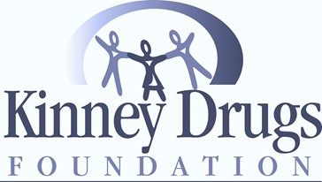

Media Sponsor:

Sponsorship opportunities are available, contact your American Heart Association representative or CheckItNY@heart.org for more information.

Implementation Guide: Blood Pressure Management

© Copyright 2023 American Heart Association, Inc., a 501(c)(3) not-for-profit. All rights reserved. Unauthorized use prohibited. WF138593 3/23

